“SECRET WISH” FASHION PHOTO ORNAMENTS
Supplies: Clear Glass Ornaments, Photo Paper, Ribbon, Jingle Bells, Permanent Marker, Glitter, Funnel, Spoon, Scissors, Tweezers, Cup, Computer/Printer
We have printed out a strip of the fashion photo portraits we took at the beginning of the party (each strip = 8 ½ x 1½in). 1) Trim the white edges off of your photo strip.
2) Take turns writing a one word “wish” on the back centre of the photo strip with the marker.
3) Gently roll your photo strip (your face facing out) into a tight cylinder.
4) The cap of your glass ornament has been removed. Leaving your ornament in the plastic cup, insert your photo cylinder into the glass ornament and allow it to unroll itself a little.
5) Take turns putting the funnel in your ornament and spooning a good helping of glitter or “secret wish dust” into your ornament.
6) Take the ornament out of the cup just long enough to retrieve the cap and the ribbon below. 7) Put the ornament back in the cup and ASK FOR HELP placing the cap on the ornament.
8) Grab the bow-tied ribbon-loop with jingle bells and place the bow and bells flush with the metal hook on the ornament.
9) ASK FOR HELP wrapping the ribbon loop over top and back through the metal hook, threading it through the loop just where it begins to split in two from the knotted bell and bow.
“SECRET WISH” FASHION PHOTO ORNAMENTS – INSPIRATION: MEISEL
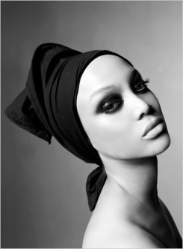
Steven Meisel is a photographer for fashion magazines such as Vogue and Harper’s Bazaar, and for famous celebrities like Madonna and Mariah Carey. He began his career as an illustrator (drawing pictures) for magazines. In his spare time, he took head-shots of unknown models. (Headshots are close up photographs like the one of Tyra Banks, here.) When those models brought their pictures to fashion magazines and agencies, Meisel’s work as a photographer became noticed. He became successful because he encouraged women to celebrate their natural beauty! For example, he helped super-model Karen Elson get her start by suggesting that she stop “plucking” her eyebrows, and he took photographs of her without make-up or elaborate hair-styling. And, in 2008, Meisel fulfilled one of his dreams, inspiring Vogue magazine editors to produce an issue featuring only African-American women. He had always wanted people of all races, shapes and sizes on the pages of fashion magazines… Meisel’s black & white photos, celebrate natural beauty, revealing a subject’s secret wishes and inner fire!!

